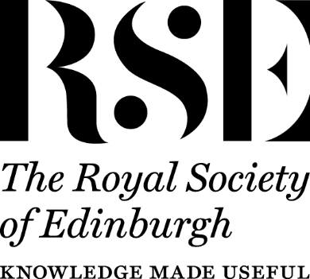
Artificial Intelligence and Scots Law: Transforming the Future
Workshop Two (Part One of Two): AI and Property Law
16 June 2025, University of Dundee
Generously funded by the Royal Society of Edinburgh
9.00-9.20 | Welcome and Refreshments
9.20-9.30 | Workshop Welcome, Dr Lorna Gillies, University of Dundee and Dr Michiel Poesen, University of Aberdeen, online
9.30-9.50  9.50-10.10  10.10-10.30  10.30-11.00 | Panel 1 – AI and Property Chairs: Dr Michiel Poesen, University of Aberdeen, online, and Dr Cody Rei-Anderson, Edinburgh Napier University, in person  Dr Sean Thomas, University of York, “What Exactly is Artificial Intelligence?” online via MS Teams.  Dr Craig Anderson, University of Stirling, “The Impact of AI on Professional Negligence, in the area of Conveyancing Practice.”  Iain Mitchell KC, Tanfield Chambers, ““AI, ethics and property law – the ghost in the machine?”  Roundtable Discussion on above (15 minutes) and tea/coffee break
11.00-11.20  11.20-11.40  11.40-12.00  12.00-12.20  12.20-12.40  12.40-12.55  (approx.)  12.50-13.45 | Panel 2 – AI and Intellectual Property Chairs: Dr Patricia Zivkovic, University of Aberdeen, online, and Dr Craig Anderson, University of Stirling, in person  Professor Henning Grosse Ruse-Khan, University of Cambridge, “Copyright and Gen AI,” online via MS Teams.  Claudia Catelin, Publishers Association, “AI and Copyright: Perspectives from Publishing,” online via MS Teams.  Roundtable Discussion on above, and short comfort break  Dr Cody Rei-Anderson, Edinburgh Napier University, “The Return of the Copyright Propertarians? Gauging Creative Industry Response to the 2024-5 UK Consultation on Copyright Law and Artificial Intelligence.”  Dr Xiaoren Wang, University of Dundee, “Creatively Misinformed: Mining Social Media for Intellectual Property Norms of Creators and Users.”  Roundtable Discussion on above (10 minutes) followed by Closing Remarks and Thanks, Dr Michiel Poesen, University of Aberdeen, online  Lunch and Close of Workshop

